Intake : APU2F2406IT(BIS)/ APD2F2406SE/ APD2F2406IT(BIS)/ APU2F2406SE

Lecturer : Tham Hoong Ching

Hand-out : 4 July 2024

Hand-in : 27 September 2024 (Week 12)

GROUP ASSIGNMENT – DOCUMENT

  - Assignment Outline:
- Line spacing: 1.5 lines
- Font Size: 12 (except titles and headings)
- Font Type: Times New Roman
- Arrangement:

Arrangement | Remarks
Cover Page
Table of Content
- “Business Process No. 1”
* Illustration/s of the business process. Sample:
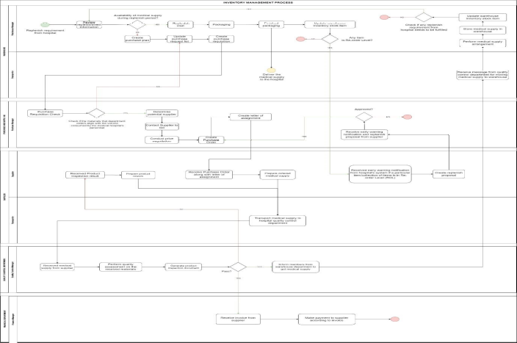
* Explain the business process in paragraph and explain how the flow in the business process. It can includes:
- what is the process, how the process flow (or activities), who are the user or department involved.
- what are the objectives of the business process.
- “Business Process No. 2”
* Illustration/s of the business process.
* Explain the business process in paragraph and explain how the flow in the business process. It can includes:
- what is the process, how the process flow (or activities), who are the user or department involved.
- what are the objectives of the business process.
- Benefits of the integration or Enterprise System (Need in-text citation)
  - Xxx
* Explanation of the benefit 1
  - Xxx
* Explanation of the benefit 2
  - Xxx
* Explanation of the benefit 3
  - Xxx
* Explanation of the benefit 4
  - Xxx
* Explanation of the benefit 5

- Successful Implementation of Enterprise System (Need in-text citation)
* The critical points should refer to the actions or steps which have to be taken by the Silvenscreen Cinemas
  - Xxxx
* Explanation of the critical point no. 1
  - Xxxx
* Explanation of the critical point no. 2
  - Xxxx
* Explanation of the critical point no. 3

Referencing | APA Referencing  Arrange in  - Source  - Alphabetical order
Work Breakdown Matrix

  - Assignment Submission:
- Online Submission through Moodle platform.
- Submit by the representative. (1 group 1 submission)
- Submit in PDF file.

DO NOT copy directly from any source including any AI platform. Read the “content”, understand it and write with your own words.
Citation is needed!!!!

ASSIGNMENT PRESENTATION

- Audience
The Management of SilverScreen Cinemas.
- Objective of the Presentation
To propose the Enterprise System to the company, and convince the company to adopt the Enterprise System.
- Duration
3 - 5 minutes individually.
- Slide or Presentation File (Maximum 9 slides)
Total Slides:
- Cover Page – Module Name, Student Name, Student ID

- Q&A
- Marking Scheme
- Presentation slide – 5%
- Presentation – 5% (individually)
- Important
    - 1 presentation file for the whole group.
    - Submit individually the presentation file to Moodle on 27 September 2024.
    - Must attend the presentation slot according to the provided schedule. The schedule will be provided in the later days.
    - Must be a formal dress code during the presentation.

